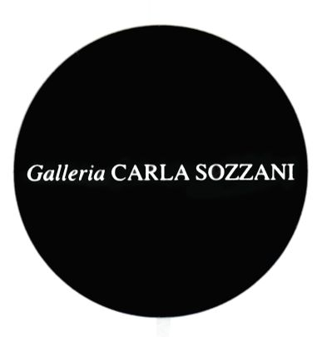

Press release

KRIS RUHS

Liquid Walls
Broken Forest

Opening
Monday April 3rd 2017, 7.00 pm

On view from Tuesday April 4th to Monday May 1st, 2017
Every day, 10.30 am– 7.30 pm
Wednesday, Thursday 10.30 am – 9.00 pm

Special Opening – Design Week 2017
4 - 9 April 2017
7.00 pm - 9.00 pm

Galleria Carla Sozzani
Corso Como 10 – Milano
tel. 02.653531 – fax 02.29004080
press@galleriacarlasozzani.org
www.galleriacarlasozzani.org

KRIS RUHS

Liquid Walls
Broken Forest

Liquid Walls - Broken Forest: the latest Kris Ruhs art room installation, will be presented at the Galleria Carla Sozzani on Monday, April 3rd at a reception with the artist at 7pm.

In keeping with previous art room installations done by Ruhs, Liquid Walls creates here another way of experiencing a light bending environment in which light, normally an unconscious part of our every-day world, takes on a major role as "object" in Ruhs' created space.

The room itself has been constructed specifically for the Galleria. One enters a 3 meter by 4 meter altered rectangle made entirely of heavily worked sheets of glass. Aggressively working materials with new techniques has always been a hallmark of this artist's work. Here, through the introduction of inks into the distressed surfaces of the glass walls, Ruhs creates a series of organic visual resistances that makes the light passing through an active, rather than passive partner in our experience. One enters into the effect of being submerged in a broken forest. This is the light one experiences when underwater and through which one cannot pass. The room places the viewer inside the piece as if on display like exotic flora.

At the center of this illuminated tank in which we find ourselves, is a small rectangular box holding another of Ruh's signature series of totems. These sculptures recall the limnal areas of our dreams - the underwater fantasies that have no name and yet we easily recognize at the heart.

biography

An artist, sculptor, and designer, Kris Ruhs was born in 1952 in New York, and studied at the School of Visual Arts, with several solo shows in NYC and LA early in his career, before moving to Italy, in 1996. Large scale installations such as "Falling to Earth" at Wapping's Hydraulic Station in London (2012), and "Hanging Garden" at Azzedine Alaïa Gallery in Paris (2016) are a small part of his oevre.

Galleria Carla Sozzani
Corso Como 10 – Milano
tel. 02.653531 – fax 02.29004080
press@galleriacarlasozzani.org
www.galleriacarlasozzani.org

