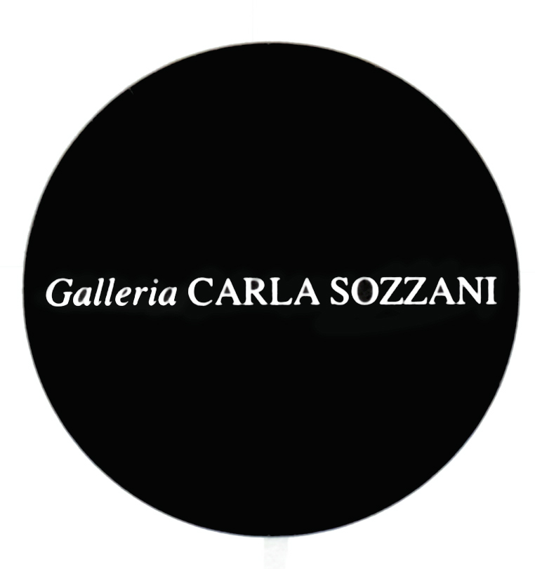

PRESS RELEASE

CHRISTOPHER MAKOS
Altered Images

Curated by Gianni Mercurio

Opening Thursday 12th June 2014
from 5.00 pm to 9.00 pm

On show from 13th june to 3rd August 2014
Everyday 10.30 am – 7.30 pm
Wednesday and Thursday 10.30 am – 9 pm

In collaboration with Madeinart
Special thanks to Ports 1961

Galleria Carla Sozzani
Corso Como 10 – Milano
Tel. 02.653531 – Fax 02.29004080
press@galleriacarlasozzani.org
www.galleriacarlasozzani.org

CHRISTOPHER MAKOS
Altered Images

Christopher Makos was described by Andy Warhol as “the most modern photographer in America".

After extensive European travel and time spent with Man Ray at Fregene, Italy, Makos moved to New York to witness the great changes of the period. Fascinated mostly by the emerging punk scene, the American photographer created a series of portraits that are unique in the history of photography: Tennessee Williams, Halston, John Paul Getty III, David Bowie, Grace Jones, Patti Smith, Richard Hell, Tom Verlaine, Alice Cooper, Iggy Pop, Divine are just some of the celebrities captured in his shots and collected in his debut book White Trash, published in 1977. He meets Andy Warhol, who was so impressed by his book, that he bought one thousand copies.

Warhol commits him the artistic direction of his book Exposure, that will be the beginning of their friendship and artistic partnership.

Inside the father of Pop Art’s late Factory, Makos captures extravagances, excesses, behind the scenes and many moments of “extraordinary” daily life of Warhol together with many superstars such as Mick Jagger, John Lennon and the young and talented artists Keith Haring and Jean-Michel Basquiat.

Makos collaborated with many magazines, like Interview, Rolling Stone, House & Garden, Connoisseur, New York Magazine, Esquire, Genre and People. His works have been exhibited at the Tate Modern in London, The Whitney Museum of American Art in New York, The Metropolitan Museum of Art in New York, and the Museo Reina Sofia in Madrid. Among his publications: Andy Warhol in China 1982 (2007), Warhol/Makos In Context (2007), Christopher Makos Polaroids (2009), LADY WARHOL (2010).

The exhibition presents a selection of 62 photographs, recalling the artistic scene of the 70s and 80s in New York. There will be presented also 8 pictures, large size images, of the Altered Images series, realized in collaboration with Andy Warhol, to represent the changeable identity of the human being, as an homage to Man Ray’s shots, portraying Marcel Duchamp’s alter ego Rrose Selavy.

