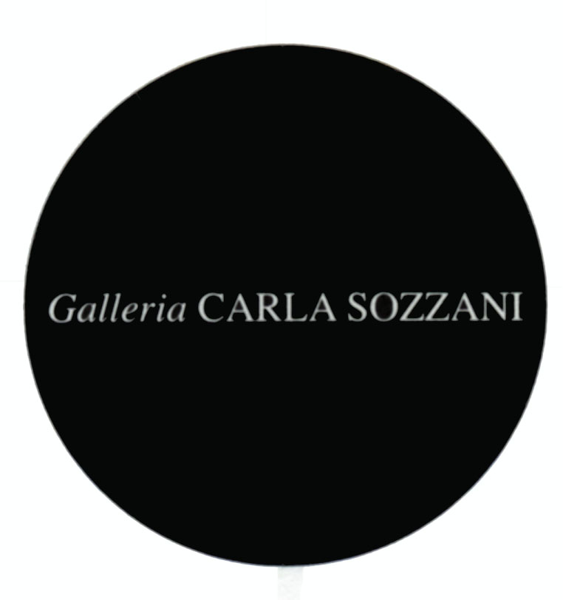

PRESS RELEASE

TONY VIRAMONTES
bold, beautiful and damned

Opening Thursday 5th September 2013

from 5.00 pm to 9.00 pm

cocktails

on show from 6th September to 3rd November 2013
Tuesday, Friday, Saturday, Sunday, 10.30 am – 7.30 pm
Wednesday and Thursday 10.30 am – 9.00 pm
Monday, 3.30 pm – 7.30 pm

Thanks to

Galleria Carla Sozzani
Corso Como 10 – 20154 Milano, Italia
tel. +39 02.653531 fax +39 02.29004080
press@galleriacarlasozzani.org
www.galleriacarlasozzani.org

TONY VIRAMONTES
bold, beautiful and damned

"I look for new ideas because I like to be in a state of creative anxiety and insecurity. If I feel sure of myself I cannot be creative, I try to renew myself."
Tony Viramontes

Damned or Doomed – history will decide. When Tony Viramontes made his debut in fashion illustration in the late 1970's he scored an immediate success, rapidly acquiring the kind of prestigious editorial commissions often allocated to photographers. From Lei, Per Lui in Italy, Vogue in the USA, the Face in Britain, as well as Jill Magazine, Marie Claire, Le Monde and City Magazine in France his client list exploded.

His strong and direct style was in marked contrast to the whispered visuals of the 70’s. By the time of his death in 1988 he had been offered creative control of Goldie and worked with some of the most celebrated names in fashion. Valentino loved him, as did Gaultier and Hanae Mori. He had drawn for Givenchy, Miyake, Yves Sant Laurant, Pierre Cardin, Ungaro and the House of Dior. Portraits of Isabella Rossellini, Paloma Picasso and Janet Jackson were in his portfolio.

Tony Viramontes was doomed to die of AIDS. In the hot and hard disco nights of the 80’s, those who were young, beautiful and gifted were idolized and loved, often by both sexes. They danced and did drugs and had wild sex and most importantly, they supported each other’s creativity – pushed each other’s visions, shared in each other’s process and created the art and fashion and music that defined the decade. Clearly, as can be seen here, it is a magnificent body of work. Now perhaps, twenty years later, can we step back to admire the humanity of it. The care and discipline he gave to each drawing. That magnificent talent grounded in a reality that he insisted be a bit dangerous and insecure. Here is the anxious reality that Viramontes needed to achieve spectacular results. A reality that would ultimately kill him.

Tony never worked from photographs. His models were hand picked and would pose for hours engaged in his creative process. Like Egon Schiele, one of his inspirations when studying art in his youth in NYC, Viramontes had an astounding grasp of anatomy. He did not distort because he could not draw, as many so-called artists attempt to do. He used his acute observation of reality to be the springboard for his work. It was observed, “He did not dream with his pencil”.

His style was fast and electric, and he would work through dozens of quickly drawn illustrations to capture the essence of a pose. The sensuous mouth, the hips and shoulders thrust out, the sass, and the scowl—these became distinctive punctuations

of Viramontes portraits. His depictions of men shared the same insolence and sensuousness he gave to his women. He boldly stretched the boundaries of masculine identity, and his models (and lovers) posed in make-up, jewelry, and exotic turbans.

As the 70’s whispered their way to the end of that decade, the 80’s, like lightning, was white light with hard edges. And when it was over, the 90’s were plunged into darkness as we scrambled to find survivors in the wreckage of a plague that still haunts us. As Fran Lebowitz noted in Scorsese’s biopic, “it was the most talented and most beautiful that everyone wanted to make love to in the 80’s, so they were the ones who died.” Doomed by their beauty, their talent, their joi de vivre – Damned for all the wrong reasons.

BIOGRAPHY

Tony Viramontes was born in 1956 in Los Angeles, USA, of Spanish and Mexican parents. He traveled extensively as a child. He studied fine art and photography in New York at FIT and Parsons, before switching to fashion and beauty illustration.
He scored an immediate success, rapidly acquiring the kind of prestigious editorial commissions too often allocated to photographers, from Lei ,Per Lui in Italy, Vogue in the USA, the Face in Britain, as well as Jill Magazine , Marie Claire Le Monde and City Magazine in France.
Viramontes also worked with some of the most renowned names in fashion including Yves St. Laurent, Valentino, Versace, Chanel, Perry Ellis, Claude Montana and Rochas cosmetics. As well as creating portraits of Paloma Picasso and Diana Ross. In 1983 he designed for the Genius Group including Goldie, Bo-Bo Kaminsky, Diesel and Replay, while in 1988 just before his death, Goldie and Hanae Mori the Japanese couturiere, asked him to take on the artistic direction of their companies, from the decoration of their boutiques to the design of their collections.

CATALOGUE

Bold, Beautiful, and Damned
The World of 1980s Fashion Illustrator Tony Viramontes
By Dean Rhys Morgan
Foreword by Jean Paul Gaultier
Afterword by Amy Fine Collins
250 illustrations
192 pages
Published by Laurence King Publishing
ISBN – 9781780673073

