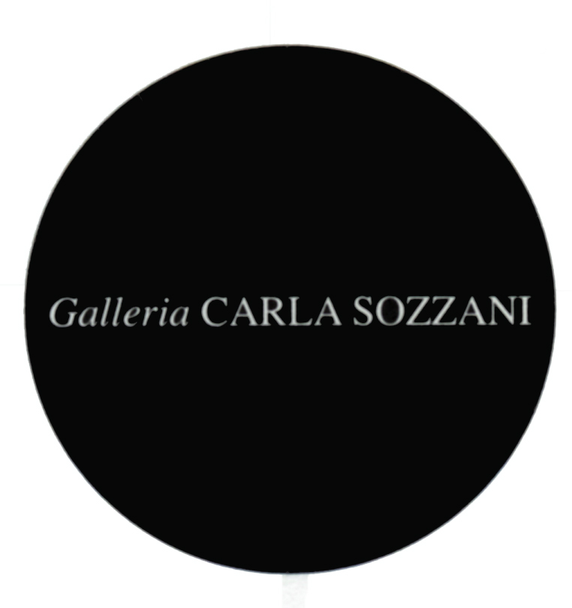

PRESS RELEASE

ANGELO MANGIAROTTI
Retrospettiva: 60 anni di attività dell'Architetto Angelo Mangiarotti

opening Saturday 6th April 2013

from 3.00 pm to 8.00 pm

cocktails

on show from 8th to 14th April 2013

everyday from 10.30 am – 9.00 pm

from 7th to 28th April 2013
Tuesday, Friday, Saturday, Sunday, 10.30 am – 7.30 pm
Wednesday and Thursday 10.30 am – 9.00 pm
Monday, 3.30 pm – 7.30 pm

The exhibition is possible thanks to the contribute of Agapecasa, Artemide, ColleVilca, Klein&More, Mepra, Unifor and Vetreria Vistosi.

Galleria Carla Sozzani
corso Como 10 – 20154 Milano, Italia
tel. +39 02.653531 fax +39 02.29004080
press@galleriacarlasozzani.org
www.galleriacarlasozzani.org

ANGELO MANGIAROTTI
Retrospettiva: 60 anni di attività dell'Architetto Angelo Mangiarotti

"Happiness comes from honesty."

Angelo Mangiarotti is one of the great protagonists of Italian culture in the 20th century. Architect, planner, designer, sculptor - he has developed an intense teaching schedule in Italian and foreign universities to convey his vision and methods, influencing generations of architects and designers.

His belief is grounded in architecture resting in the practical. Sober and functional, industrial design is an expression of craftsmanship, respecting the materials being used and their honest application.

After graduating from the Politecnico of Milan in 1948, Angelo Mangiarotti, embraced the ideals of the Modern Movement, and then seriously pushed beyond them, creating innovative works that combine the economy of means and the aesthetic quality of the structures. Mangiarotti has expressed this theoretical basis in the book "Nel nome dell’architettura", published in 1987. It highlights the intrinsic characteristics of each object - a design "objective" that is recognized and accepted by the community at large.

Interpreter of a rigorous functionalism, Mangiarotti has never stopped pursuing the ideals of beauty and elegance, rationality and industrial production, integrity of form and simplicity. Gifted with an eclectic creativity his projects range from jewelry, tables and furnishings, office systems, vases, lamps, tableware to houses, industrial facilities, and urban renewal projects.

In recent years he has devoted himself increasingly to sculpture, which he began in the 80s. His sculpture is a synthesis of his philosophies and design: matter and form, design and its relationship to man and environment.
His motto: "Happiness comes from honesty" identifies his civic sense and the ethics expressed in his profession. This philosophical approach offers a unique and exceptional reference in all his works.

The Galleria Carla Sozzani is proud to offer a retrospective of Mangiarotti’s extraordinary career. Through drawings, study models, design objects, photographs, sculptures and films from the Archive Studio Mangiarotti in Milan, we hope to convey a sense of the breadth of his influence in design and architecture in the 20th century.

ANGELO MANGIAROTTI BIOGRAPHY

Born in Milan in 1921.

He graduated in Architecture in 1948 at Politecnico di Milano.
In 1953-1954 he works in the United States, participating also to the competition for Chicago “LOOP”. While leaving abroad he knew Frank Lloyd Wright, Walter Gropius, Mies van der Rohe and Konrad Wachsmann.

By coming back from United States, he opened an architectural firm together with Bruno Morassutti until 1960.

In 1989 he founded Mangiarotti & Associates Office based in Tokyo.

From 1986 to 1992 he’s art director of Colle Cristalleria.

Mangiarotti, while working as an architect whose works are published on books, specialized magazines and newspapers, had an intense didactic activity made in different Italian and foreign Universities. In 1953-1954 he is a visiting professor at the Institute of Design of the Illinois Institute of Technology in Chicago; in 1963-1964 he’s professor in a course of Istituto Superiore di Disegno Industriale of Venice; he’s visiting professor at University of Hawaii in 1970, at the Ecole Politecnique Fédérale of Losanna in 1974, at University of Adelaide and at South Australian Institute of Technology of Adelaide in 1976; in 1982 he has a contract as professor at the Faculty of Architecture of Palermo; in 1983 he is supply professor for the course of composition at the Faculty of Architecture in Florence, in 1989-90 he has a contract as professor in the graduation course in Industrial Design at the Faculty of Architecture of Politecnico di Milano. He participated to many international seminars and conferences.

Dies in Milano in 2012

His design work is marked by a lot of prizes received both in the field of design and architecture:

- Domus Formica Prize (1956)
- In/Arch Prize for Lombardia (1962)
- First Prize in the National Prize of Industrial Design of La Spezia Gulf (1963)
- AIP-Associazione Italiana Prefabbricatori Prize (1972)
- Prix Européen de la Construction Métallique (1979)
- Medal and honorary degree at III Mundial Biennal Exhibition of Architecture in Sofia (1986)
- First prize at “Concorso Targa Alcan” (1989)
- Special mention at In/Arch National Prize (1989)
- Design Plus Prize for “Ergonomica” collection (1991)
- Marble Architectural Awards (1994)
- Compasso d’oro ADI for carrier (1994)
- “Honoris Causa” degree in Engineering, Technischen Universitat of Munich (1998)
- Gold Metal in Architecture category - Accademia della Torre di Carrara (1998)
- “Honoris Causa” degree in Industrial Design, Politecnico di Milano (2002)
- Gold Metal for “Apostolo del Design” from Rima Editrice (2006)
- Marble Architectural Awards 2007, special mention
- Prix “ArchitettiVerona” istituto dall’Ordine degli Architetti P.P.C. di Verona (2009)

