PRESS RELEASE

CARLO VALSECCHI
Lumen

curated by Nathalie Herschdorfer and William A. Ewing

Opening Wendsday 7th September 2011
from 5.00 pm to 9.00 pm

On show from 8th September to 13th November 2011
Tuesday, Friday, Saturday, Sunday, 10.30 am – 7.30 pm
Wednesday, Thursday 10.30 am – 9.00 pm
Monday, 3.30 pm – 7.30 pm

This exhibition, produced by the Musée de l’Elysée, Lausanne

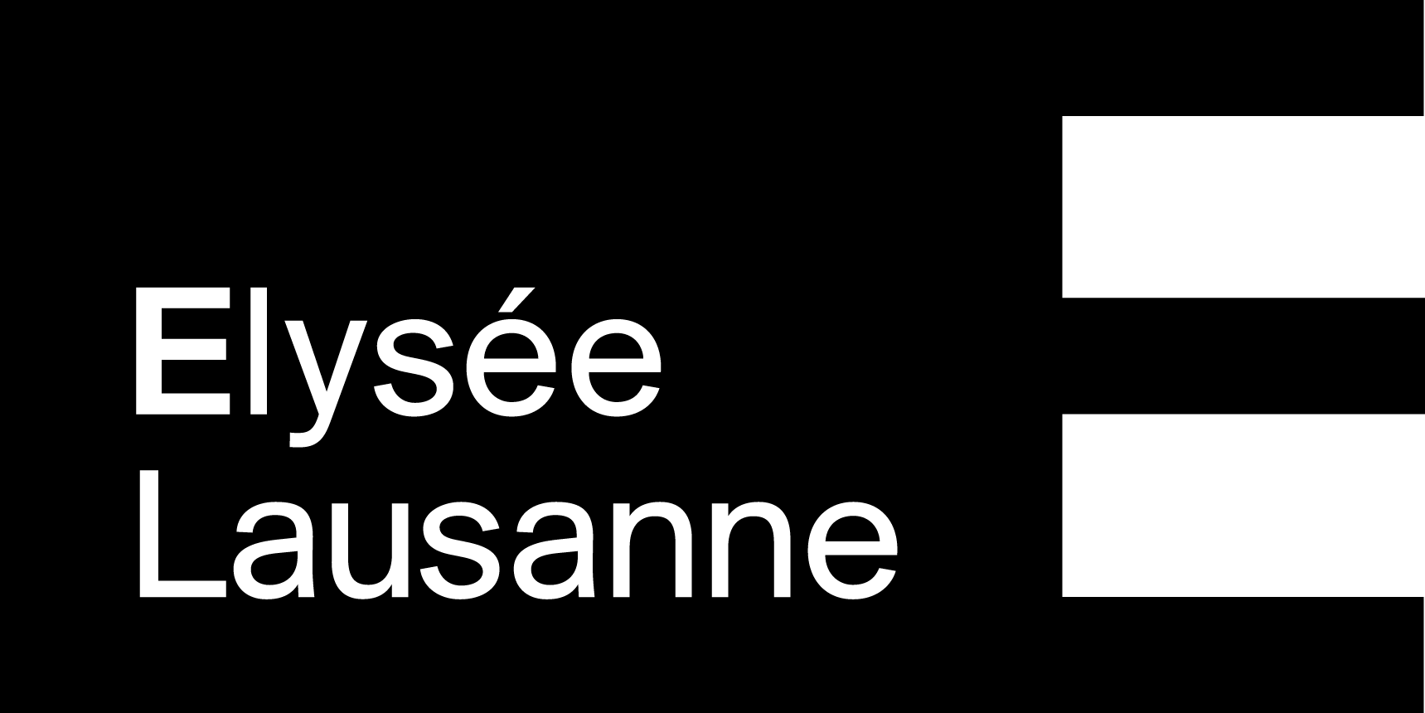

Galleria Carla Sozzani
Corso Como 10 – Milano
tel. 02.653531 – fax 02.29004080
press@galleriacarlasozzani.org
www.galleriacarlasozzani.org

CARLO VALSECCHI
Lumen

From monumental industrial architecture to the interiors of strange machines; from night views of cities flickering like active volcanos to gleaming high-tech laboratories; from neat boxes of fruit or vegetables to the sprawling agro-industrial farmlands of Argentina, Carlo Valsecchi alternates between the near and the far, between precise figuration and poetic abstraction. His large-format photographs, devoid of human presence, often take unexpected vantage points, which, while initially destabilizing our perception, then encourage us to engage more actively with the image.
In Valsecchi work, there is no dualistic split between the subjects he engages with and his mental vision of them; rather, there is ongoing interaction between what the artist sees, his understandings of it and the creative outcome.

Although much of his work is clearly within the strong tradition of the industrial landscape developed by the German school (Becher, Gursky), Valsecchi has found his own expressive register. His approach is characterized by meticulousness of composition and framing, systematic use of natural light, large format images evocative of paintings and a subtle handling of color often restricted to pastel tones or tending toward the monochromatic.
In one series after another, the photographer plunges us into places rendered splendidly visual, he creates the marvelous by setting out to render all the immensity of places sensed, captured and understood through photography. Rejecting documentary, he is striving for something more detached from reality, something more painterly. The oeuvre is shot through with non-photographic references: from the New Objectivity painters in German and their interest in the industrial, and the pictorial grandeur of American Abstract Expressionists, to the canvases of Lucio Fontana, who sought to extend painting’s limits by stressing light and space at the expense of form and texture.

He lives and works in Milan.

SOLO EXHIBITION
2011 Galleria Carla Sozzani, Milan;
Museo di arte moderna e contemporanea di Trento e Rovereto (Mart), Trento;
2009 Musée de l’Elysée, Losanna;
2006 Triennale di Milano, Milan;
2005 Fondazione Rosselli, Turin;
2003 GAMeC, Bergamo;
Guido Costa Projects, Turin;
Galerie 213, Paris;
2001 Studio Casoli, Milan;
Galerie 213, Paris;
2000 Foundation Peggy Guggenheim, Venice;
1999 Istituto di Cultura Italiano, New York.

GROUP EXHIBITION

2002 'Il fantasma della liberta', la sparizione dell'immagine nella fotografia italiana', a cura
di Marco Meneguzzo, Spazio Erasmus, Milan;
'Le Bati, Le Vivant', Chapelle du Rham, Luxembourg;
'Numero Zero', Guido Costa Projects, Turin;
1998 '37 cornici per 37 fotografi', a cura di Marco Romanelli, Association Jacqueline
Vodoz et Bruno Danese, Milan;
1996 Triennale di Milano, Milan;
1992 Biennale di Architettura, a cura di Paolo Portoghesi, Venice.

